NJLA-CUS/ACRL-NJ Research Committee Annual Report, 2016-2017

Membership
Cynthia Coulter agreed to serve as chair for the next year, 2016-2017.
Aileen Bachant | Rowan University
Susan Bucks | Monmouth University
Heather Cook  Cynthia Coulter | Caldwell University  Hudson County Community College
Melissa Hofmann | Rider University
Mei Ling Lo | Rutgers University
Karen Pifher | Somerset County Library System
Mary Beth Weber | Rutgers University

Meetings
There was one meeting on Maarch 11, 2016. All member attended to select winners from the Award and Forum submissions. Mei Ling Lo graciously provided space in Rutgers Tech Serv Conference Room. In attendance were Susan Bucks, Melissa Hofmann, Mei Ling Lo, and Cynthia Coulter.

NJLA-CUS/ACRL/VALE User’s Conference
Cynthia submitted a poster proposal, which was accepted. The poster was displayed at the VALE Convention along with a new member enrollment sheet that produced one new member, Mary Beth Weber.
NJLA CUS Newsletter articles
Cynthia submitted an article for the Spring Newsletter calling for nominations for the 2017 Research Award & Forum.
Research Award and Forum winner announcement were sent to NJLA/CUS Newsletter Committee. The NJLA/CUS Marketing & Communications committee were contacted, to place announcement on Facebook and Twitter. Cynthia posted announcement to NJLA CUS Drupal site.
Award and Nominees
Requests for Research Award and Forum presentations nominations were sent by email to several library organization listservs, in November, December, January and February, for the March deadline. This call for submissions was also be sent to NJLA CUS Marketing & Communications Committee. It was too late to send to the Spring Newsletter Committee.
There were eight award submissions and no forum submissions.
The winners of the 2017 NJLA/CUS and ACRL/NJ Research Award & Forum
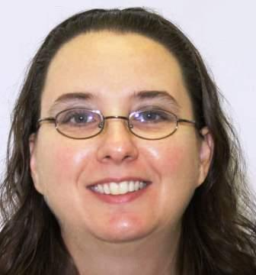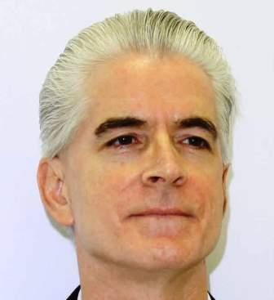
Dr. Michelle Kowalsky & John Woodruff, both from Rowan University, for their book, Creating Inclusive Library Environments: A Planning Guide for Serving Patrons with Disabilities
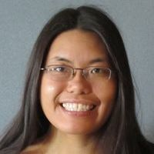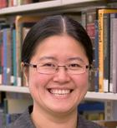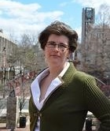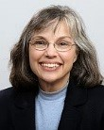
Bonnie L. Fong , Minglu Wang, Krista White, and Roberta Tipton, all from Rutgers University, for their Journal of Academic Librarianship article, Assessing and Serving the Workshop Needs of Graduate Students
NJLA 2017 Annual Conference
The 2017 convention was held at Harrah in Atlantic City, NJ. The theme was “Beyond the Box!” New this year, Heather Dalal introduced the Research award winners at the Tuesday evening general NJLA Awards Ceremony. It has been discussed that maybe the nominees might present the Tuesday evening award, if possible.
A formal presentation of the Research Award took place at the College and University Section’s luncheon on Wednesday, April 26th, 2017. The Research Award & Forum presentation was held in the same late afternoon session as the Technology Award presentations. This was the first time that the NJLA planning committee decided to combine the Research and Technology awards during a single afternoon session, instead of the usual double session. Melissa Hofmann graciously hosted the award ceremony since Cynthia Coulter could not make the convention.

ACRL Five-Year Goals and Objectives
Through the presentation and explanation of their research, the speakers at the Research Award & Forum help to promote ideas, practices, and current pedagogical theories, not only in librarianship, but in student learning and faculty instruction.
Thus, the NJLA/CUS ACRL-NJ College & University Section Research Committee has helped to address the following recommendations of the ACRL Plan for Excellence:
- Increase research that demonstrates the value of academic and research libraries.
- To improve outreach to higher education organizations in order to articulate the value of libraries in higher education.
- Increase partnerships with other organizations to advance the impact of Information Literacy on student learning.
- Increase understanding of new models of information fluency as pedagogy evolves.
- Increase the ways ACRL is an advocate and model for open dissemination and evaluation practices.
- Influence scholarly publishing policies and practices toward a more open system.
- Enabling programs and services for education, publication, advocacy, and member engagement.

