NJLA-CUS/ACRL-NJ Executive Board Meeting Agenda/Minutes
Friday October 18 2019, 10AM

Online via Zoom

I. Welcome and introductions

Present: Cara Berg, Heather Dalal, Janelle Bitter, Adriana Mamay, Gary Marks, Eric Jeitner, Linda Salvesen, Joan Dalrymple, Joe Louderback, Bonnie Lafazan, Amanda Cowell, Sharon An, Leslin Charles (guest attendee)

II. Approve September meeting minutes: https://docs.google.com/document/d/1qss3kEJLVdXM9D1t1eBUmy5QmChrLHaAKxaVD7MxKUs/edit

No abstentions or opposition; passed

III. Reports (Executive Board and Committee Chairs, see below for more details)

IV. Old Business
- Bylaw amendments Both amendments approved unanimously 10/18/2019

Discussion on Article VII about whether to include names of positions; decision not to as this would require editing the bylaws each time they changed. Positions and responsibilities should be listed in some kind of policies doc instead.

Exec board will work on editing and getting new bylaws uploaded to Drupal site - this will then be migrated over to new Memberclicks site. Old bylaws will be downloaded and saved in NJLA Google drive.

V. New Business
- Chairperson for Strategic Planning

Chair should be someone who has in-depth knowledge of how CUS functions, members should be mix of new and experienced members
Heather and Bonnie will co-chair, Cara and Alyssa on it by default, Janelle also interested
Gary will serve as bylaws liaison, but not be officially on Strategic Planning committee
Contact Heather, Bonnie, Cara or Alyssa if interested in joining

- Alyssa – we should have a webinar for academic librarians who might want to submit to NJLA committee – will get a date (due Nov. 30, maybe end of Oct.) – Adriana will participate as committee planning person
- Gary - how will Strategic Planning Committee affect bylaws work? Should he continue to find volunteers for the task force? No, new committee will find them or be them
- Katie had daughter - Molly, born mid-Sept.

Reports (Executive Board)
- President (Cara Berg)
  - Members Council report
  - Memberclicks
  - NJLA Conference
- Vice President (Alyssa Valenti)
  - CUS Luncheon update
“The Academic Appetite” – networking
Slideshow of past CUS events – marketing to get more members
Icebreaker activities at tables – academic library bingo
1.5 hours, buffet
Still have to propose it – Alyssa will summarize everything by Monday and send it out to us
If you are not in that group, feel free to email Alyssa
  - VALE Breakouts
Quick turnaround, met on Oct. 10
25 accepted proposals, including roundtables – 5 of these/lightning talks
Ocean Place, Long Branch, Jan 8 2020

- Past President (Bonnie Lafazan)
- Assisting with the planning of the CUS Luncheon
- Met with VALE Breakouts Committee
- Secretary (Janelle Bitter)
No report.
- Member at Large (Karen Venturella, Bart Everts)
No report.
- NJLA Executive Board Liaison/Honors and Awards Liaison (Adriana Mamay)
  - I attended the NJLA Executive Board meeting this past Tuesday, October 15th in Paterson.
  - As of November 1, the old NJLA website will no longer exist and the Memberclicks website will be exclusively used. If you are an NJLA member, you should have received emails asking you to create your own password. Please follow the link and do this by November 1st to continue receiving emails and notifications from NJLA. You have the ability to select which sections you would like to receive emails from. Once you log in and find “My Profile”, click on “My Features” then “E-lists” and then you can select which groups you want to be on the e-list for. 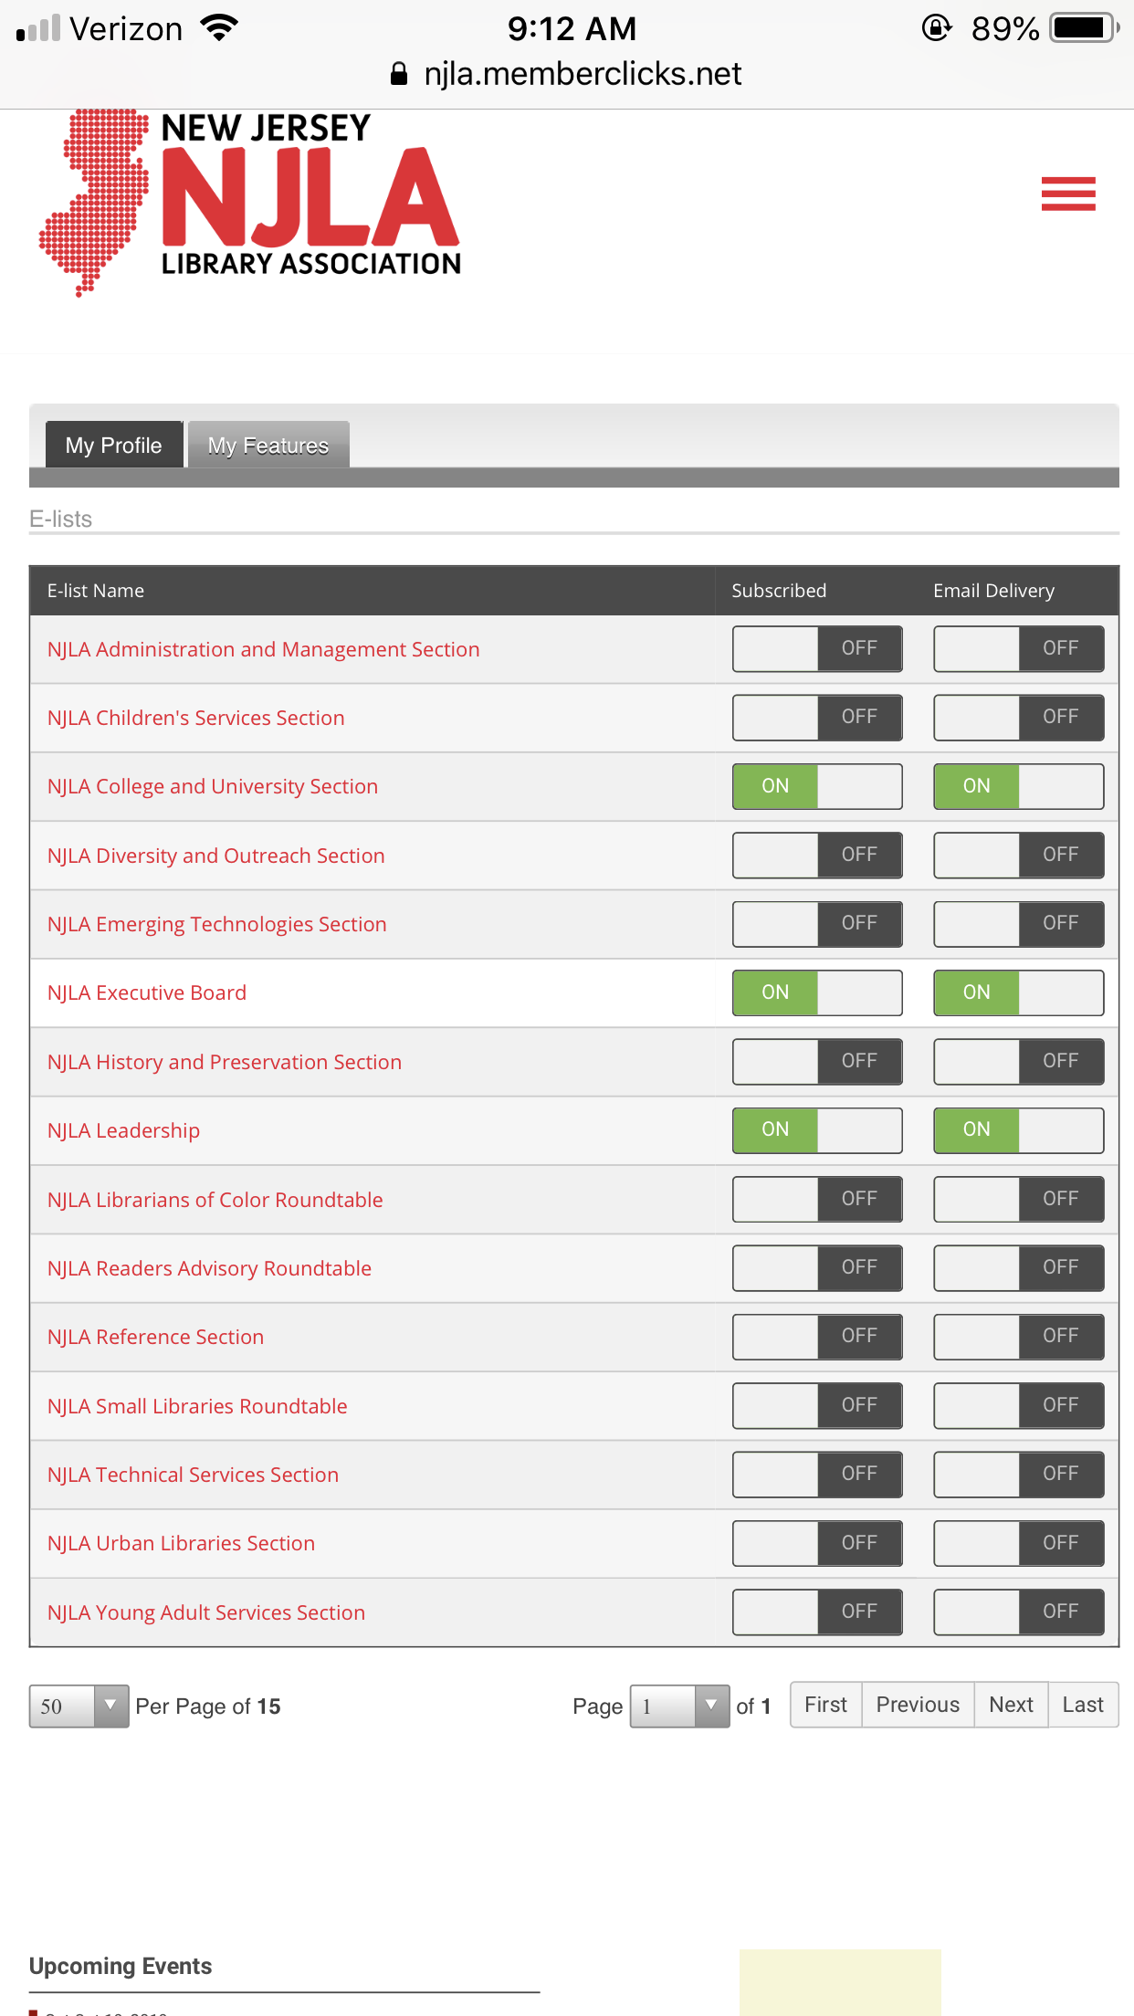

  - Ballots to fill the vacant Member at Large position on the NJLA Executive Board should be sent out to all NJLA members today. Leslin Charles is on the ballot! Make sure to vote by November 1st.
  - I attended the NJLA Honors and Awards Committee meeting on October 8th.
  - Awards will be accepted through an online form from November 29th to March 16th.
  - The committee is working to add a *new* award that honors innovative programming. This is open to all libraries. Many academic libraries host programs throughout the year that are worthy of recognition, so I’ll share the details about this award once they are finalized.
  - Now that the submission dates have been set, I will send an email out to the 4 CUS awards contacts with details. Are these the correct contacts? BCMC - Martha Loesh; Distinguished Service - Alyssa Valenti; Research - Heather Dalal; Technology - Amanda Cowell

Adriana shared her screen to demonstrate Memberclicks. After logged in, go to Home > Member Home > My Profile > My Features > E-lists (this is screenshot shared above)
When you click on CUS, can email from there or copy/paste that address
Members – only 60 people so far, probably have way more on the old one
A lot of them not academic librarians which is cool because they want to know about us – newsletter, meetings
2 toggles – can subscribe without getting emails?

Adriana will figure out how people (Gary, Joan, Amanda, etc.) can get access to edit new Memberclicks site
Can add yourself to any section, but for CUS committees you will get added
Does this eliminate NJLA CUS listserv? Yes – have to go thru Memberclicks to contact section (we think, Adriana will double check)

Luncheon plug – let us know if you have prizes you can donate, will also attempt to acquire

- Website Liaison (Romel Espinel)
No report.
- Legislative Representative (Gary Marks)
  - Mozilla v. FCC decision- NJ free to move forward with A1767 & S1577 “New Jersey Net Neutrality Act”
NJ was waiting on ruling, states can now create own policies
  - Census 2020 resources - 1st year that majority of census is being done electronically – families will receive links to fill out info
  - eBooks for all ALA petition - MacMillan – limiting libraries ability to purchase or embargo going in place Nov. 1 – petition to change, primarily effect public libraries but could move to academic (like embargo for databases)

Reports (Committee Chairs)
- Archives (Heather Perez and Brianna LoSardo)
- Assessment (Christina Connor and Eric Jeitner)
  - 9/27 - Held an online meeting - Meeting discussion around article reading, meeting next Friday
- Bibliographic Control and Metadata (Sharon An)
Just had meeting Oct. 10 – new member from William Paterson.
Formed task force for Tech Services award, communicated with Adriana.
Committee discussed mission statement – add bullet points to reflect mission of ACRL. Will have further discussion on March 19.
VALE – BCMC will participate with poster, brochure description of committees tasks, goals, activities, continuing ed, etc.
Provide more continuing ed through workshops, demos.
After meeting, BCMC members from NJ5 Alma – discussion – challenges, workflows.

- Marketing and Outreach (Hilary Westgate and Linda Salvesen)
  - Our committee met on Tuesday, October 1st using Zoom. We had a great meeting with great attendance and discussed readings about the use of Instagram by academic libraries. (The Zoom option through NJLA worked well.)
  - Following our meeting, a group of us submitted a proposal for a breakout session for the VALE Conference: Supporting Inclusion Through our Libraries’ Marketing and Outreach Efforts
  - We received an NJLA intern! She has a background in marketing and will help us with our social media and other initiatives/projects. We plan to meet with her via phone soon (probably 10/29) - Julie worked in academic publishing for 15 years.
  - NJLA CUS Marketing & Outreach Award idea: Hilary is contacting Adriana to review the details for this process. Then, we hope to talk with the rest of our committee to determine the criteria and protocol for judging.
- Newsletter (Joan Dalrymple and Katie Cohen)
- Third call went out this week.
- We have received several announcements, but need more articles.
- I have not heard back from SCARLA yet. I will be reaching out to committees and others for articles.
Last call will be Oct. 28, deadline is Nov. 4, goes out on Nov. 11
Next one is in April
Marie Radford – not sure if elected officers for SCARLA. Students wrote article last year
Would like intern, wondering about status – based on background, our one person was given to Marketing - Heather offered student from Rider
Example topics for articles?
Update on OER (not sure what Melissa Lena is writing) – institutions speak to what they’ve done
Thinking of presenting at VALE/follow up at NJLA
Efforts – i.e. people came together with Alma
Elimination of overdue fines (Alyssa)
Cara is supposed to write something too
Intern working with the section – will get in touch with Hilary and Linda
Chairs can remind members of committees - Sharon will communicate with committee to write something, can hold space if not ready by Nov. 4
Name change for user ed group – write a little something about that (Joe)
Blurb about VALE conference (will Melissa do that, Cara)
Adriana will write something about awards

- Nominations (Steve Shapiro)
No report.
- Reference and User Education Committee(Amanda Piekart and Joe Louderback)
- The committee had their first meeting of the year on 10/11
- They finalized their name and description (see below)
- The Reference and User Education Committee* is a subcommittee of the New Jersey Chapter of the Association of College and Research Libraries and the College and University Section of the New Jersey Library Association. The function of the committee is to promote lifelong learning as an educational goal, and to support the pursuit of excellence in library user education programs and reference interactions. The Reference and User Education Committee produces professional development programs on enhancing reference services, teaching and learning in libraries. Additionally the committee disseminates information about information literacy, user education and reference services, and serves as a forum for the discussion of these topics.
- The committee discussed a list of topics to discuss at future meetings, such as: The role of the library liaison, virtual chat reference & staffing models, first year experience support, and assessment in IL instruction
- Discussed sharing more practical “this is how I am doing this at my institution” perhaps having one committee member share at each meeting.

Will be meeting again Nov. 8

- Research (Heather Dalal)
We will have our first meeting of the academic year on October 29th. Will talk about how to promote awards. Many members of committee are not experienced, so need to reach out to people who can be mentors.
Adriana – NJLA has corresponding session for award winners of Research and Technology – need to talk about whether want to continue having, how to do because competing against all other sessions.

- Technology (Amanda Cowell)
- We met through zoom on Friday September 27th.
- We had a good turn out and discussed topics including future meetings, possible future projects and ways to better promote our award.
Talked extensively about NJLA – definitely want to continue having that
It is an incentive for award, choose tech that is repeatable so people who attend session can reproduce

