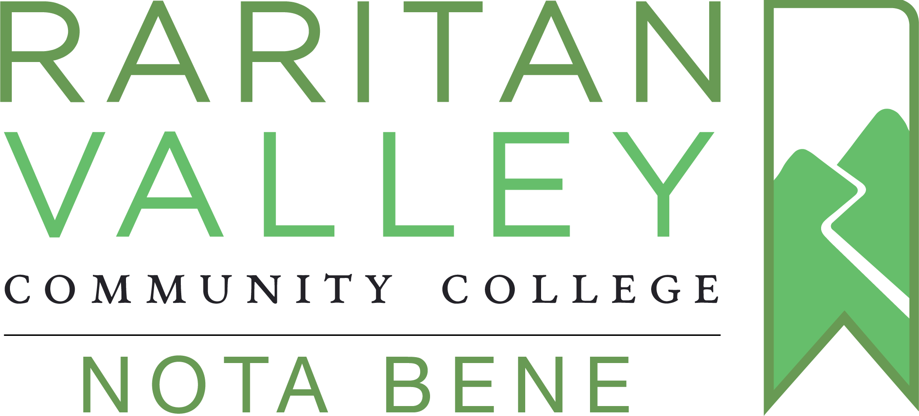

Nota Bene 2022-2023

Each academic year, Nota Bene celebrates the creative spirit and ingenuity of our students by showcasing outstanding student work from across our curriculum. Submissions are nominated by our professors and collected each fall and spring semester. Students nominated for their work from the 2022-23 academic year will be honored in a special event on April 19, 2023, at 6 p.m.
General Guidelines:
- Faculty members are the judges for Nota Bene – send us your students’ best work.
- A faculty member may submit one piece per student.
- A faculty member may submit up to three entries per academic year.
- Any medium or type of project from any discipline is eligible: business plans, poetry, inventions, essays, videos, dance, and any other media.
- DEADLINE: January 31, 2023 (fall 2022); March 31, 2023 (spring 2023)

Instructions for Submissions:
- Student work should be submitted by the professor in a digital format (MS Word, Powerpoint, PDF, etc.) and e-mailed to Nota.Bene@raritanval.edu.
- If work cannot be digitized, please, contact Nota Bene at Nota.Bene@raritanval.edu.
- Each entry must be accompanied by an online submission form completed by the student:
https://forms.office.com/r/L4CPPYFFv9

Submission Criteria:
- Pick a work created in any one of your classes in response to your prompt
- Do not simply identify the best student in your class – we are looking for especially creative ways of addressing the prompt
- Choose assignments that embody creativity (not limited to artistic creativity) and inventiveness: our past submissions include a golf cart, a project for medical practice, and a book cover design
- Pick wisely! There is no further judging process, and all nominated students get an award
- We encourage but do not require interdisciplinary submissions: a poem in a Business Law class, a drawing for Biology
- We accept submissions from all disciplines

